Tarantula

1. How to install

- Go to http://meshing.at/actVersion/tarantula2.2.01.tar.gz to download the file.
- Untar by typing “tar zxvf tarantula2.2.01.tar.gz” into the command line.
- Move the files to Documents (or preferred location).
- (OPTIONAL) Set an alias to “<your install path>/bin/linux/voxmesher” so that the file can be executed without typing out the full path each time.

        - e.g. alias vox= '/home/username/Documents/Tarantula2.2/bin/linux/voxmesher'

- Then execute “<your install path>/bin/linux/voxmesher -licinfo”.
- Email the generated file 'licinfo.dat' to get the license generated.
- 'splitter.table' will be emailed back. Download this and copy to .../Files/.

2. How to generate a simple mesh

2.1 Generate a simple voxel data set (or download)

- The voxel data set must be in plain-text file format.
- The data set can be broken down into a header, and the data.
- In the header list the number of voxels in each axis and then the size of the voxels (size is unitless – how you should number the size depends on the program you will use later on).

        - e.g. 3 x 3 x 3, with 1m resolution:

3 3 3
1 1 1

- Each voxel should then be represented by an integer. A 0 indicates that a voxel is not part of the mesh, 1 or more indicates a voxel is part of the mesh.

        - Voxel data for our example:

3 3 3
1 1 1

0 0 0
0 0 0
0 0 0

0 0 0
1 1 1
1 1 1

1 1 1
1 1 1
1 1 1

2.2 Write a configuration file (.conf)

- MESHFILENAME is the name given to the generated mesh
- VOXFILENAME is the name of the voxel data set.
- Add TETRAHEDRIZE so that a tetrahedral mesh is generated (optional).
- Other parameters can be set. There is a guide on parameters in the Tarantula manual which can be found in .../Tarantula2.2/doc
- The .conf file should be saved in the same directory as the voxel data set.
- Configuration file for the example (example.conf):

MESHFILENAME mesh.spm
VOXFILENAME voxel.vox.gz
ISO_REFINEMENT_LEVEL .5 3
BASEH 1
END

2.3 Execute Voxmesher

- Voxmesher can now be executed with the configuration file using “/<your install path>/bin/linux/taraview”. You must be in the directory containing the configuration file and voxel data set.

        - e.g. /home/username/Documents/Tarantula2.2/bin/linux/voxmesher example.conf

- If the mesh has been generated successfully, it should appear in the same directory as the configuration file with the name given in the configuration file.
- If a 'Floating point exception' message appears then a mesh has not been generated. This can be fixed by checking for errors in the configuration file. Possible errors are:

        - Not being in the correct directory.
        - Typing errors in configuration file.
        - Typing errors in command line.
        - Where 2^{BASEH} larger than the size of the stack. Try a smaller number.
        - Incorrect name of voxel data set (e.g. mixing up zipped and unzipped versions).

3. How to view the mesh

- After voxmesher has been executed a mesh should be generated in the directory with the MESHFILENAME given in the configuration file.
- Type into the command line “<your install path>/bin/linux/taraview” to execute taraview.

        - e.g. /home/username/Documents/Tarantula2.2/bin/linux/taraview

- The mesh can then be opened by going to “File”, “Open” and then selecting the file. Alternatively type the name of the file into the command line when executing taraview.
- Turn the mesh on by selecting the name of the mesh in the left hand column and then clicking on “Rending” in the top toolbar and checking the “Wire frame” box.

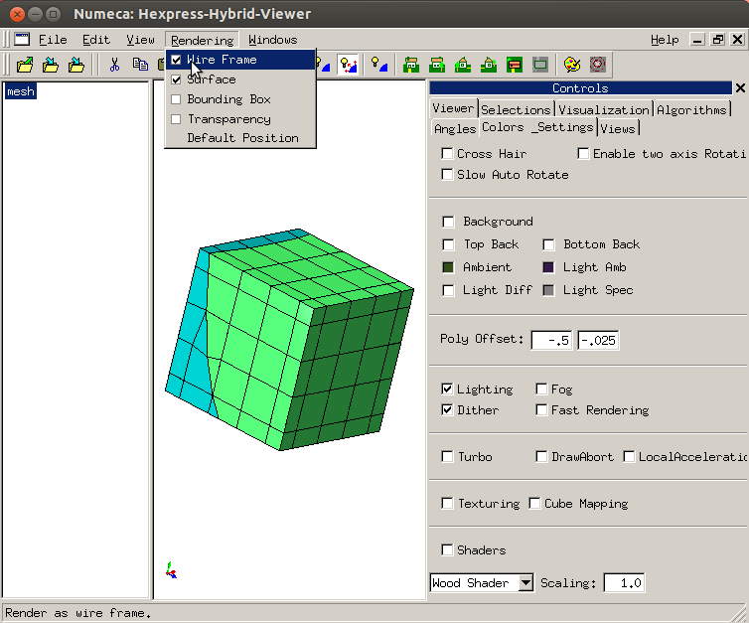
Viewing example mesh.spm

- By default Tarantula generates a hybrid mesh. A pure Tet-mesh can be generated by adding “TETRAHEDRIZE” to the configuration file. In order to create a pure Tet–mesh in the Taraview GUI, select the name of your mesh in the left hand column and go to “Controls” on the right hand side, select “Algorithms”, “VolumeAlgorithms” and then “tetrahedrize”.

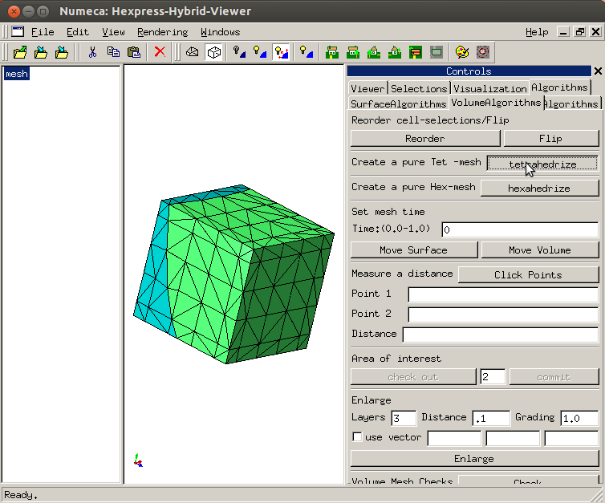

- A multi-material mesh is generated. In order to see just one material (e.g. view all the mesh made out of ones and remove the zeros), go to “Controls” on the right, then “Selections” and “Selection List”. Check the material you wish you see, and leave the material you wish to remove unchecked. Then click apply changes.

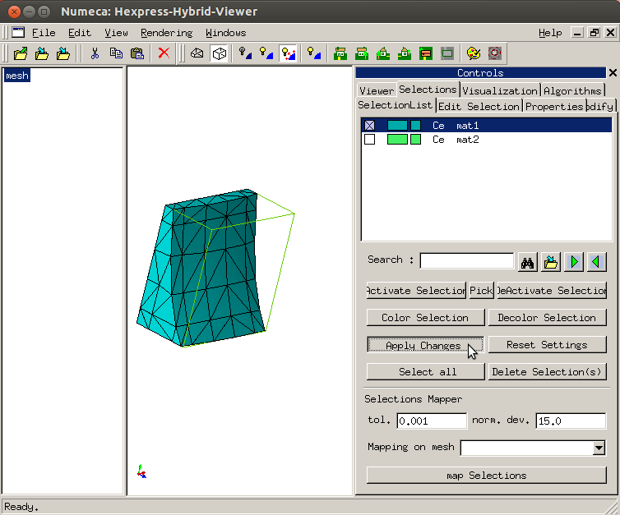
mat1 in example mesh.spm

4. Deleting cells

Deleting a selection only deletes the selection and not the cells contained. To delete the cells contained within a selection, activate that selection and deactivate the selections you want to keep. Then click on the cut symbol in the tool bar at the top. This can then be saved.

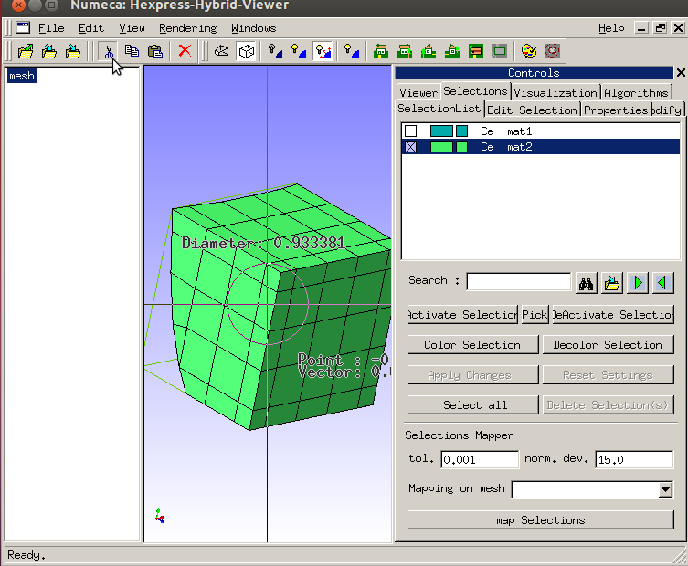
Deleting mat2 from example mesh.spm

For the real rocks mat2 (solid rock) was deleted leaving just the rock pores. The rock pore meshes were used later on for flow simulation.

5. Resolution of meshes

The parameter BASEH sets the maximum width of cells. A power of 2 must be given as the length of a voxel in Tarantula is defined as 1-1-1.
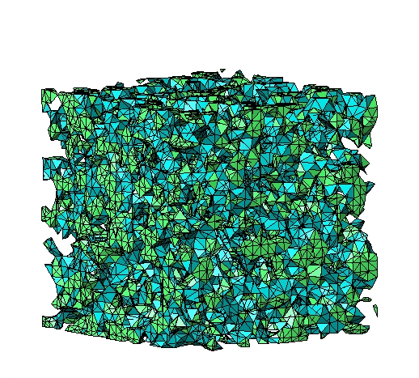
Real example 1

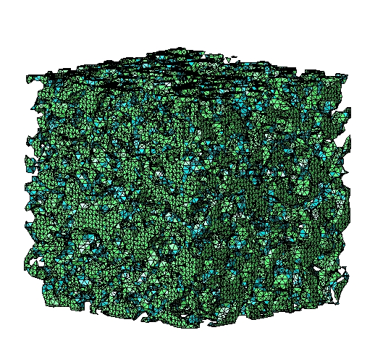

Mesh for rock pores. Upper image is of lower resolution, with BASEH set at 8. Bottom image has BASEH set at 1.

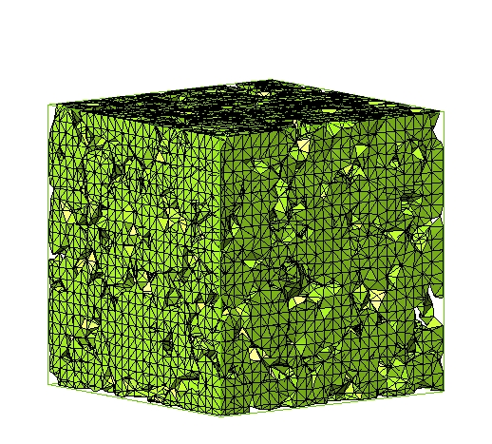

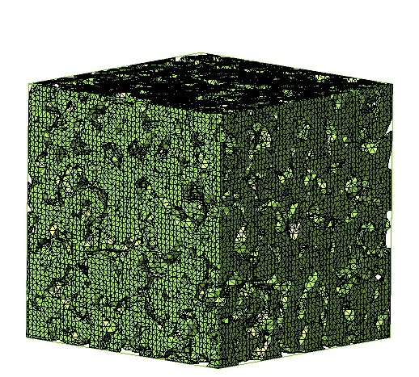

Mesh for rock. Upper image is of lower resolution, with BASEH set at 8. Bottom image has BASEH set at 1.

Real example 2
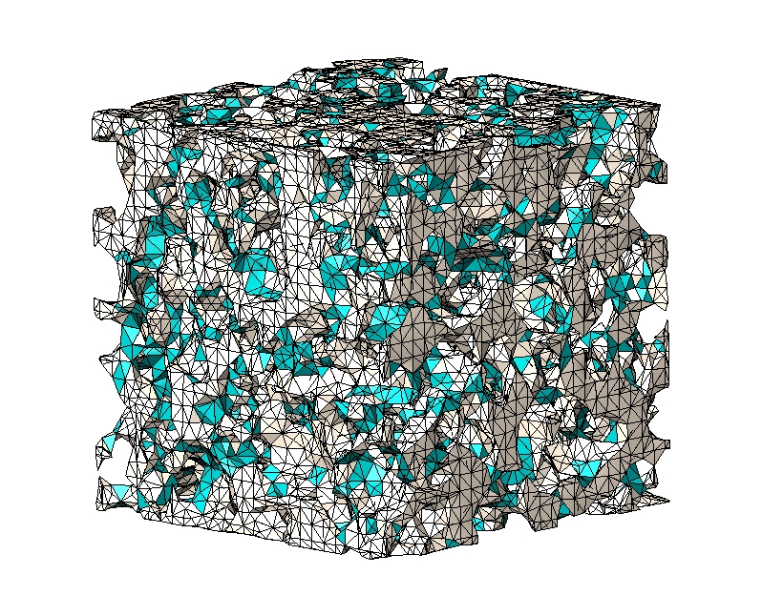

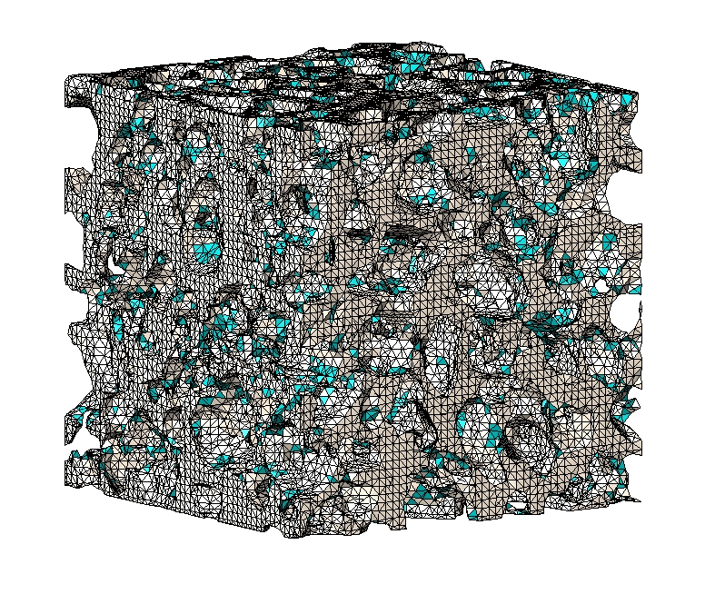

Mesh for rock pores. Upper image is of lower resolution, with BASEH set at 16. Bottom image has BASEH set at 8.

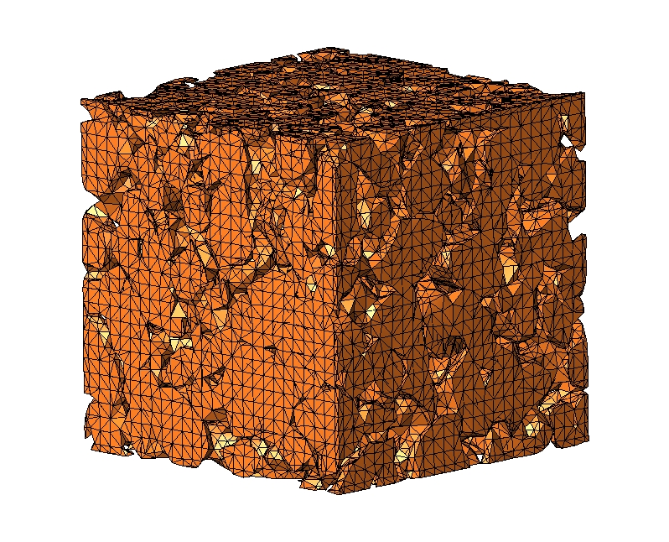

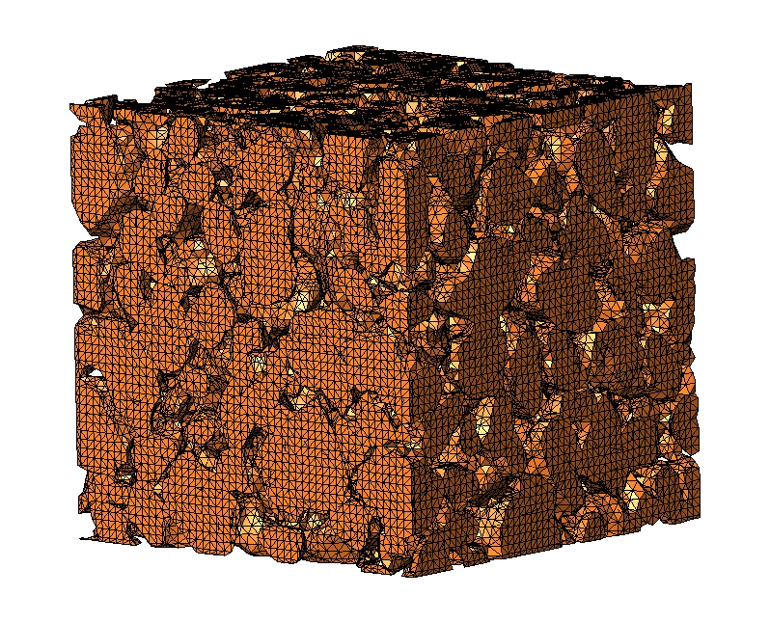

Mesh for rock. Upper image is of lower resolution, with BASEH set at 16. Bottom image has BASEH set at 8.

6. Generating meshes from real geometry voxel data

Real geometry voxel data for rocks was used. The meshes were separated into pore meshes and rock meshes so that the geometries can be examined separately. With complicated meshes, generated from real geometry, a third material (mat0) is often formed. This material is on the interface between other materials and it is not clear to the mesher where to put it. It can be added to either mat1 (pores) or mat2 (solid rock).

6.1 Sandpack LV60
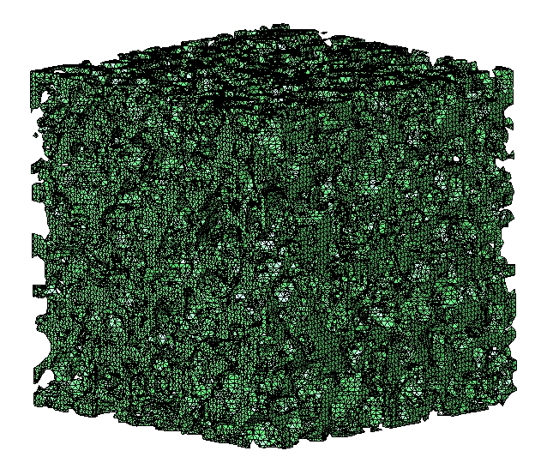

Mesh for sandpack rock pores

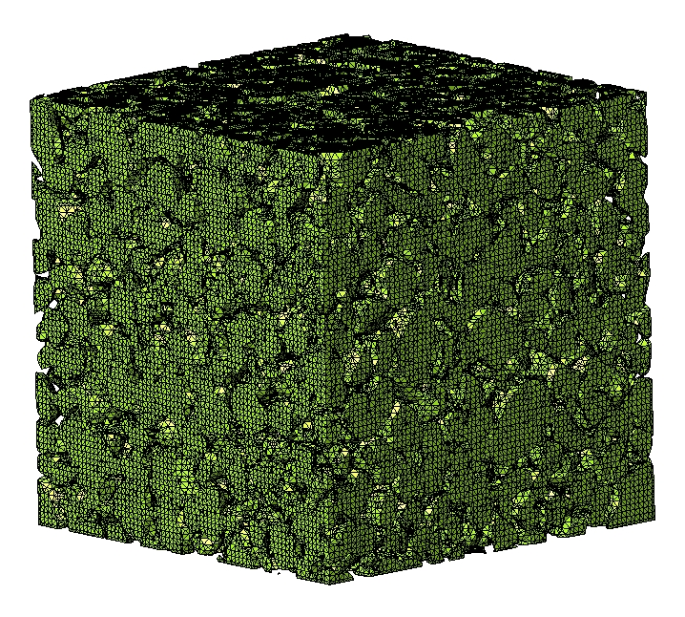

Mesh for solid rock

6.2 Sandstone S1
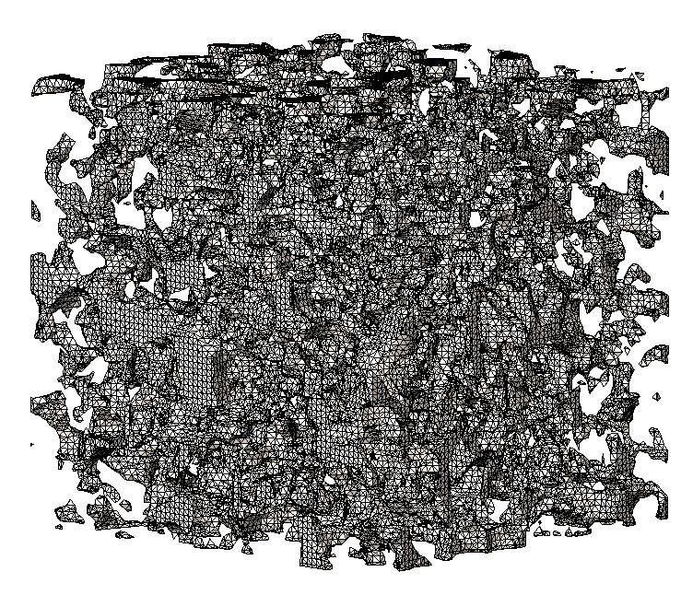

Mesh for sandstone rock pores
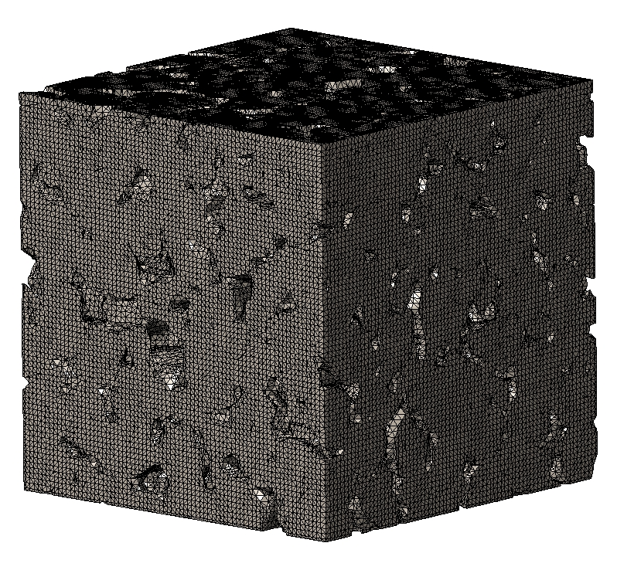

Mesh for solid rock

6.3 Carbonate C1

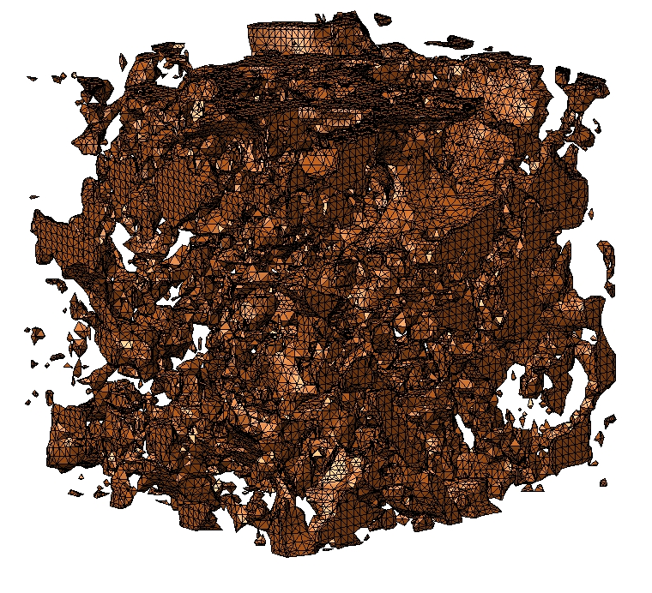

Mesh for carbonate rock pores
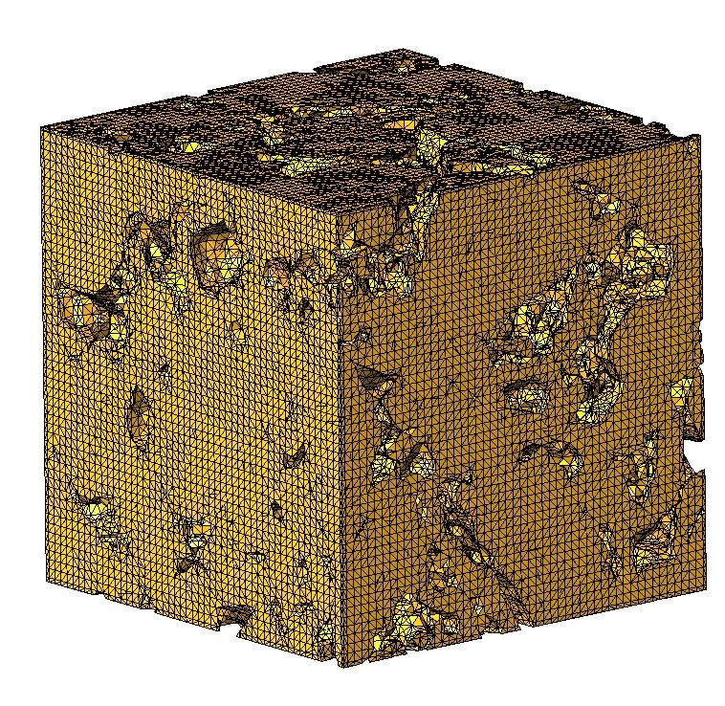

Mesh for solid rock

7. Setting boundaries

7.1 External Face Selections

Boundaries for a mesh can be set by making face selections using the GUI. In the controls menu there is the heading “Selections” and under that “Edit Selections”.

A new selection was made for each face of the meshes. The pick mode was set to “add by angle”, the the side being added was clicked on.

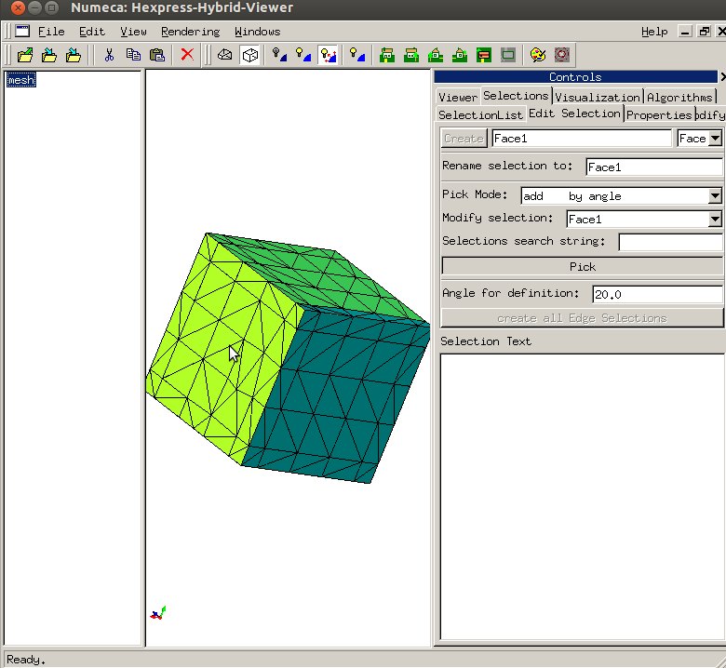
Making a face selection on example.spm

7.2 Interface Selection

In our simple example mesh, we can just turn off one of the materials so that we can see the interface and then make that a face selection as above.

For more complex meshes there are a few more steps.

Go to the SelectionList and check the box for one of the materials and click “Apply Changes”. This should deactivate other materials so that only one can be seen. If this is a single material mesh then this step can be skipped.

A new face selection called “Interface” needs to be created. Then Pick mode should be set to “add by normal” and then the Angle for Definition should be set to 90.

Click on “Pick”. Then keep clicking on the mesh until the whole mesh turns into the colour of the new face selection. In order to rotate the mesh, “Pick” will have to be deselected, and then reselected again after rotation.

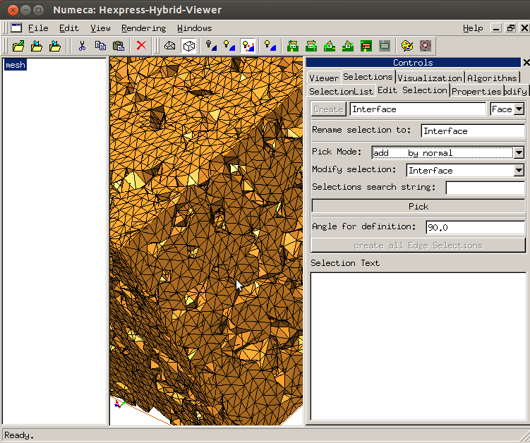

Once the whole mesh has become the same colour. Deselect “Pick”. Active all of the materials in the SelectionLis (if a this is a multi-material mesh)t. Then go back to editing the selection by changing Pick mode to “remove by angle”. Then change the Angle of definition to 10. Select “Pick” and then click on the faces of the box until all of them return to their original colours.

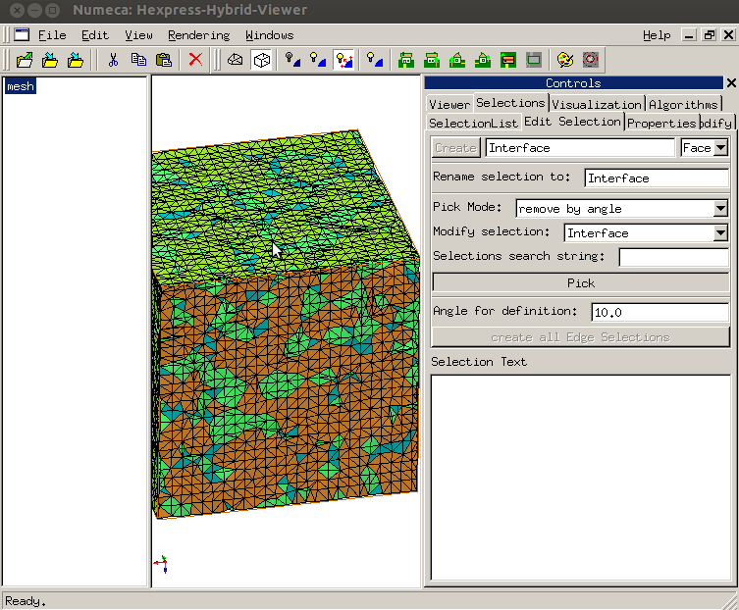

You can return to the SelectionList and deactivate the other material again. You should be able to see the interfaces are still coloured.
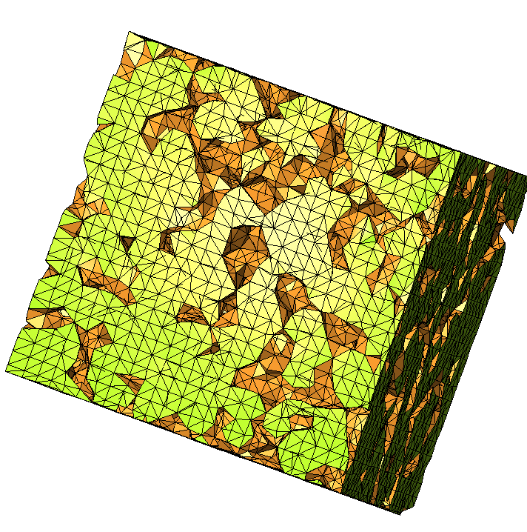

8. Converting to Triangle format

The native format for Tarantula is .spm. The generated meshes need to be converted to Triangle format so that they can be read by Fluidity.

8.1 .node file

A .node file contains the total number of vertices, their dimensions and the coordinates of the vertices. This information was extracted from the .spm file, each vertice was numbered and then and added to a .node file using code written in Python.

Format for .node file is:

First line

<total number of vertices> <dimension> 0 0

Remaining lines

<vertex number> <x> <y> <z>

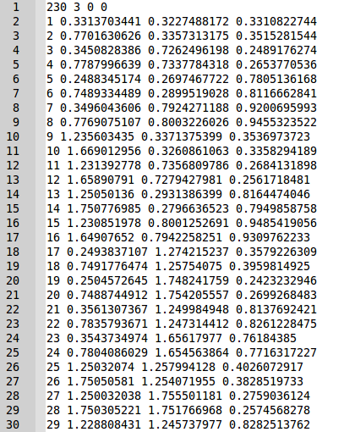

First 30 lines of mesh.node file for example

8.2 .ele file

A .ele file contains the total number of elements and their nodes. This information was extracted from the .spm file and added to a .ele file in the appropriate format using code written in Python.

Format for .ele file is:

First line

<total number of elements> <nodes per element> 1

Remaining lines:

<element number> <node> <node> <node> <region id>

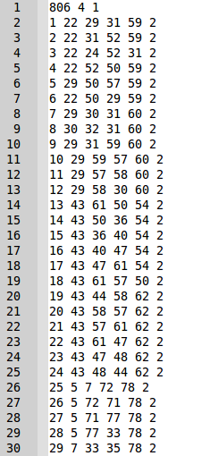

First 30 lines of mesh.ele file for example

8.3 .face file

A .face file contains the number of faces, and the nodes for each face. Boundaries were set as described in
section 7. Setting boundaries and the information was then extracted from the .spm file and added to a .face file in the appropriate format using code written in Python.

Format for .face file is:

First line
<total number of faces> 1

Remaining lines

<face number> <node> <node> <node> <surface id>

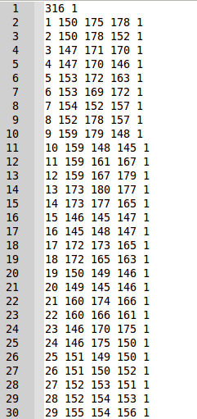

First 30 lines of mesh.face file for example

The codes written were combined to make a single program. The program could be executed from the command line along with the name of the .spm file to be converted. The .spm file must have six face selections named Face1, Face2 ….Face6 and three material selections named mat0, mat1 and mat2. Some code was added to the end of the program to also produce .vtu files from the data which can be read by Paraview. More detailed meshes with larger .spm files took several hours to convert to triangle.

9. Fluidity

simulation
multi-phase computational fluid dynamics code

9.1 Diamond

The simulation is configured using a GUI called diamond.

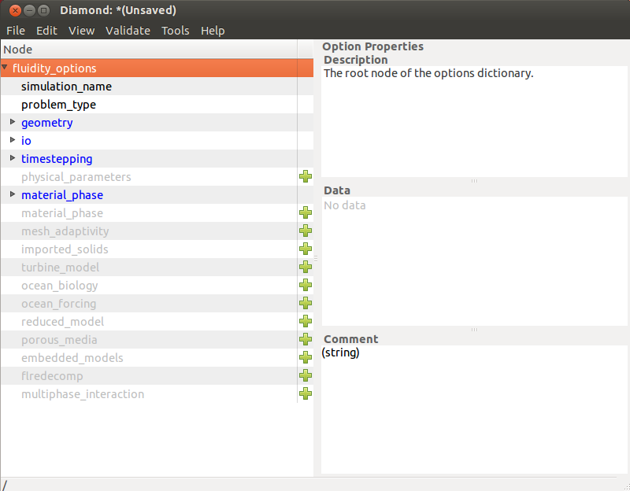
A screen shot of the GUI display is shown above. Sections that have not been completed are coloured blue. More options can be included in addition to the compulsory elements shown. The different options are explained in the manual for Fluidity - https://launchpadlibrarian.net/122076607/fluidity-manual-4.1.8.2.pdf

This information is saved as a .flml file. It should be saved in the same directory as the .node, .ele and .face files for the mesh.

9.2 Running simulation

be in directory containing flml file
command line → fluidity optionfile.flml
output- VTK format
.vtu files will appear in the same directory

9.3 Viewing results

Paraview – can view all of the .vtu files. Can view as an animation.

